First Grade
School Supply List 2018-2019

$7.00 for Scholastic News magazine subscription (please send in an envelope labeled with your child’s name)

1 Large zippered pencil case (no plastic boxes, please; they don’t fit in our desks)

6 sturdy folders with bottom pockets (Writing, Homework, Classwork, Tests, Guided Reading, 100 Book Challenge) (plastic/coated folders last longer)

1 Large eraser

1 Box of crayons (16 or 24 only, please)

Scissors

Glue Sticks (these will need to be replaced throughout the year)

Pencils (please send 4 sharpened pencils to school each day) NO MECHANICAL PENCILS- THESE WILL BE SENT BACK HOME

1 Primary Composition Book/Journal with picture space at the top 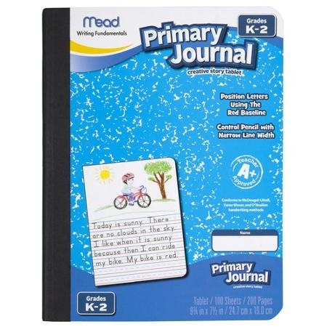
Dry Erase markers, with a small cloth or old sock to use as an eraser

2 Boxes of Tissues

Pack of disinfectant wipes

1 pair of earbuds (in a ziplock bag labeled with your child’s name)

Wish List items (appreciated but not required )

Roll of paper towels

1-2 Packs of copy paper

