Dobson One Book

Summer Activity
Catalogue

4667 Umbria Street
Philadelphia, PA 19027
215-400-3570
CONTENTS:

Family Fun-Time in the Summer-Time …………….………. page 1
City of Philadelphia Municipal Day Camps ….…………… page 2
Philly Region Summer Fun Guide ………………………..…… pages 3 & 4
100 Fun Things to Do With Your Kids This Summer …. pages 5 & 6
80 Outdoor Activity & Game Suggestions for Kids …… pages 7 & 8
10 Simple STEM Activities for Kids …………………………… pages 9 & 10

100 Fun Things to Do With Your Kids This Summer
Suggestions for creating memories that they'll have for a lifetime –
or at least for that first day back to school when the teacher asks, "What did you do this summer?".

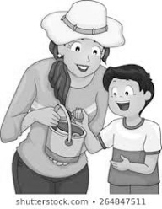
- Bake cookies for ice cream sandwiches.
- Volunteer together at a nature center.
- Make a photo journal or a family yearbook.
- Have a luau in the backyard.
- Visit the beach and collect shells.
- Make a fort out of cardboard boxes.
- Visit a farmer's market and/or pick fresh berries.
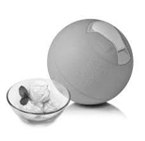
- Stage an A-to-Z scavenger hunt, where you have to find something that starts with every letter.
- Have a picnic at a state park.
- Make ice cream. Try using YayLab's ice cream ball, which you fill with ice cream base and kick around until frozen.
- Go canoeing at a local lake.
- Build a sandcastle.
- Write and illustrate your own book and have it published into an actual hardcover book using IlluStory.
- Set up an ice cream sundae buffet for dinner.
- Clean up trash at a park in your neighborhood.
- Have a backyard campfire ... or just use the grill! Roast hot dogs on sticks, pop popcorn and finish off with s'mores.
- Make homemade pizza.
- Go for a nature walk and then make a collage from objects you find along the way.
- Head to a creek and look at the ducks.
- Set up a lemonade stand and raise some money for a good cause.
- Have a water balloon toss ... or fight!
- Practice your origami skills and make construction paper crafts to hang from the ceiling.
- Go biking on a trail.
- Interview a grandparent or an older relative about what life was like when they were young.
- Plan a picnic at a local park — or in your backyard.
- Visit the local library throughout the summer and try to read as many Caldecott medal books as you can.
- Create salad spinner art by placing circles of paper inside a cheap salad spinner, dab tempera paints on top, cover and spin.
- Practice making interesting shadow puppets and then put on a show with your characters.
- Plant a garden of herbs and veggies.
- Make a sidewalk chalk mural and invite the neighbor kids to join in the fun.
- Go ice blocking (sledding) on grass with a towel-covered block of ice.
- Have an outdoor painting party using huge canvases or cardboard.
- Visit a fish hatchery.
- Plant a butterfly garden with flowers.
- Pretend to be pirates for a day — dress up in costumes, plan a treasure hunt and talk like a pirate.
- Make an indoor "sandbox" -mix 4 c of rice, 3 T of rubbing alcohol, and a few drops of food coloring; let it dry overnight.
- Turn the backyard into a carnival — set up a face painting area and games like ring toss.
- Make totem poles out of paper towel rolls and decorate them.
- Visit a museum you've never been to.
- Make a giant hopscotch or Twister game on the lawn (with spray paint) or driveway (with chalk).
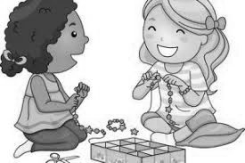
- String beads into jewelry.
- Make a bird house out of Popsicle sticks.
- Learn about stargazing and identify as many constellations as possible
- Create leis with wildflowers.
- Go fossil hunting near a lake.
- Break out your baseball glove and start a game, sandlot style.
- Make paper boats and race them in a kiddie pool using straws to propel them.
- Play mini-golf — or set up a course in your driveway by laying different size containers on their sides.
- Make a sand art garden and plant a succulent.
- Get a map of the United States and mark off all the exciting places you want to visit — create the ultimate road trip.
- Set up a net and play badminton and volleyball. Or try one of these other backyard games for kids.
- Visit an amusement park or water park.
- Wade through a stream and search for minnows or tadpoles.
- Go zip-lining.
- Have a tricycle race at the park.
- Investigate an ethnic grocery store and make lunch using interesting spices and kid-friendly international recipes.
- Visit a fire station.
- Collect rocks and paint them to use as paperweights or pet rocks.
- Go roller skating.
- Visit a zoo or aquarium to learn about animals.
- Run through the sprinklers.
- Blend your own smoothie — they're good for you!
- Set up a bike wash and raise money for a local charity.
- Batter up at a batting cage.
- Let kids paint the sidewalk or patio with water and sponge brushes. When their creation dries, they can begin again.
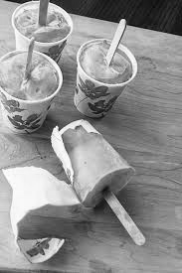
- Bake cupcakes in ice cream cones and then decorate them.
- Assemble a family cookbook with all your favorite recipes.
- Go horseback riding.
- Make popsicles in Dixie cups using fruit juices.
- Catch fireflies in a jar (and let them go at the end of the night).
- Stage your own Summer Olympics with races, hurdles and relays.
- Create a backyard circus — kids can pretend to be animals and dress up as clowns.
- Decorate bikes and have a neighborhood Fourth of July parade.
- Take a sewing/crochet/knitting class.
- Make Mexican paper flowers using different colored tissue paper.
- Go to a flea market.
- Volunteer at an animal adoption organization.
- Visit a retirement home and read stories to residents.
- Attend an outdoor festival or concert.
- Pick a nearby town to visit for the day.
- Visit a cave.
- Mark off all the local parks on a map — then visit them, take pictures and vote for your favorite.
- Take in a fireworks exhibit.
- Make crafts with recyclable items like stickers using old photos, magazines and repositionable glue.
- Make your own hard-to-pop bubbles - 1 c of distilled water, 2 T of Dawn dish soap and 1 T of glycerin.
- Paint canvas sneakers with fabric paint pens or acrylic paint.
- Create three-dimensional buildings using toothpicks and mini marshmallows.
- Make bird feeders by covering pine cones with peanut butter and rolling in birdseed.
- Paint with ice by freezing ice cube trays with washable tempera paint.
- Create unusual s'mores with ingredients like cookies, bananas, mini candy bars, flavored marshmallows & white chocolate.
- Have a fancy tea party.
- Make a giant slip-n-slide with a painter's tarp and shaving cream.
- Go camping in the backyard or at a campsite.
- Let kids paint each other with washable tempera paint and then wash it off in a sprinkler run.
- Visit a national park and help the kids earn a junior ranger badge.
- Go to a ballgame and learn how to keep a scorecard.
- Set up a tent in the backyard to use as a summer playhouse.
- Take a free kid's workshop at stores like Lowe's, Home Depot, AC Moore, Michael’s Crafts, or Pottery Barn.
- Have a game night with charades, Pictionary and bingo.
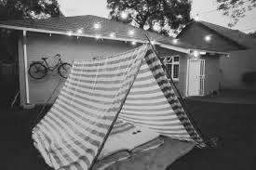
- Let kids brainstorm creative things to do with a boring brown paper bag — you'll be surprised at how many things you can come up with.

80 Outdoor Activity & Game Suggestions for Kids

It's important for kids to get outside and play. First of all, it's fun. But it's also good for them. There are actually many more health benefits to playing outside besides just getting kids up and moving. Playing outdoors helps them get fresh air, much-needed Vitamin D from being out in the sunlight, and it can help relieve stress. Getting children into the habit of playing outside at a young age is important to their growth and development.

- Play a sport such as baseball, basketball, soccer, football, kickball, or hockey
- Kayak or canoe on a lake or river
- Go for a run/jog together
- Play golf or go to the driving range
- Go to the batting cages
- Ride your bike
- Play ultimate Frisbee
- Play volleyball
- Play catch
- Do yoga
- Set up circuit training
- Play tennis
- Play Frisbee
- Jump on a trampoline
- Set up relay races
- Play hacky sack
- Play cricket
- Build a fort
- Barbecue lunch or dinner with burgers, hot dogs and s'mores
- Set up lawn games like bocce ball, croquet, horseshoes, corn hole and ladder ball
- Go swimming
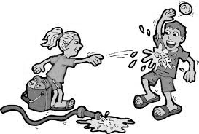
- Visit a water park
- Have a water balloon fight
- Go puddle jumping
- Play pool games like Marco Polo and water tag
- Build a sandcastle at the beach
- Set up a slip and slide
- Search for seashells
- Play tag
- Play jungle gym games like sandman and gravel
- Play hide and seek
- Jump rope
- Play hop scotch
- Play ‘Four Square’
- Play basketball games like horse and around the world
- Play wall ball
- Play ‘Capture the Flag’
- Play ‘Duck, Duck, Goose’
- Play on the jungle gym like on the swings, slide, and monkey bars
- Use a hula hoop
- Play marbles or jacks
- Race toy cars or balls
- Draw with sidewalk chalk
- Blow bubbles (use different-shaped wands to make fun shapes)
- Create and have the kids do an outdoor scavenger hunt
- Paint rocks
- Make bird feeders
- Tie-dye T-shirts
- Make your own craft using flowers, leaves, twigs, pebbles, and other things found in nature
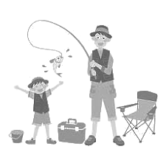
- Go rock climbing
- Do archery
- Go to a shooting range
- Go horseback riding
- Rollerblade or skateboard
- Make an obstacle course
- Go fishing
- Go to the zoo
- Take your dog for a walk or to a dog park
- Go bird watching
- Catch fireflies
- Hunt for bugs
- Make a garden
- Pick flowers
- Pick fruit in an orchard or garden
- Go to a local nursery or botanical garden
- Make a compost
- Have a picnic
- Go hiking or camping
- Gaze at the stars
- Climb trees
- Play in the mud
- Dig a hole
- Make a sundial
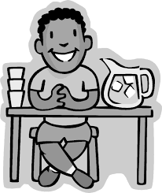
- Set up a lemonade stand
- Jump in a bouncy house
- Go miniature golfing
- Make up some silly dances
- Make a bonfire in the evening
- Sing campfire songs
- Make up a new game, and share it with friends

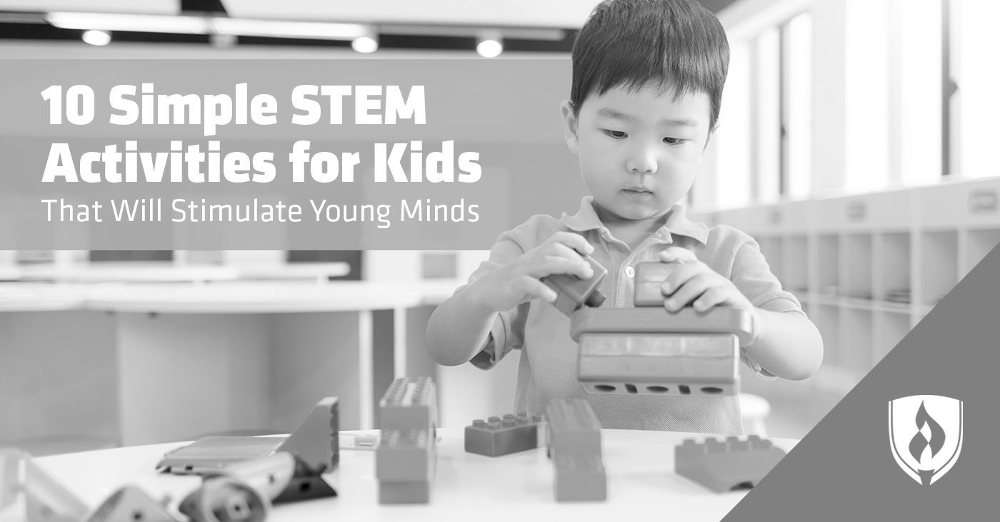

It doesn’t take a rocket scientist to know that STEM (Science, Technology, Engineering and Math) subjects are vital pieces of our children’s education and lives.
1. Magnetic slime Category: Science
For this activity, you’ll need a few special ingredients so be sure to plan ahead. When you’re finished, your kiddos will get to experience an ooey-gooey slime that seems to magically move when exposed to neodymium (rare earth) magnets.
https://frugalfun4boys.com/make-magnetic-slime/

2. Homemade catapults Category: Engineering
In this activity, you’ll help your children get excited about engineering by building a homemade catapult with jumbo popsicle sticks and rubber-bands. You can even incorporate some science in as well by hypothesizing which objects will fling farther and then following through with the experiment.
https://littlebinsforlittlehands.com/popsicle-stick-catapult-kids-stem-activity/

3. Oil spill activity Category: Engineering/Science
Why not try an activity that will connect back to real issues? In this activity, you simply mix oil and water in a large container and add a few feathers to the mix. Then pass out materials that might help the kids remove the oil from the water, such as sponges, paper towels or little spoons. Have the kids try to remove the oil without removing too much water. You can use this activity to show how oil spills can affect the environment, by helping them see how the oil affected the feathers and how difficult it was to remove it from the water. You can also use this activity to talk about the type of engineers that work to handle environmental issues. http://scienceafterschool.blogspot.com/2012/07/oil-spill-connecting-stem-activities-to.html

4. Coding a Lego maze Category: Technology
In this activity, your child or student (as early as kindergarten) can begin to learn the basics of coding. With the free printables provided, including different mazes and instruction cards, your child will get to put themselves in the shoes of the “user” (Lego person) and start to line up different codes (instructions) in order to guide their Lego person through the maze. https://researchparent.com/coding-a-lego-maze/
5. Hot Ice Category: Science
This activity will take a little longer, so prepare the kiddos to wait out the process by telling them it’s worth it. In the end, they will get to see an “ice” crystal appear nearly out of thin air, and you’ll help them get a glimpse into the scientific process of nucleation. The great part? This project only needs two common household ingredients: vinegar and baking soda. https://www.playdoughtoplato.com/kids-science-experiment-hot-ice/

6. Lego addition Category: Math/Engineering
For your kiddos who love Legos, incorporate some simple math into their play. Create additions cards for young ones (e.g., 3 red + 2 yellow) and more difficult math challenges for the older kids (e.g., 2 x 2 blue). Then let them build towers to find and display their answers. https://thestemlaboratory.com/lego-addition-cards/

7. Easter egg addition Category: Math
In a slight modification of this activity, all you need are some plastic Easter eggs and a sharpie. On one half of the Easter egg, write the math problem and on an opposite half write the problem’s solution. Then mix up the problems and solutions by connecting different halves together. Have your child or student unscramble the eggs, matching each problem with its correct answer. You can even make it an egg hunt to add another element of fun! https://thestemlaboratory.com/telling-time-matching-up/

8. Jellybean building Category: Engineering
All you’ll need is a pile of jellybeans and toothpicks for you student or child to start learning about structures. By connecting toothpicks with jellybeans, encourage your child to see which shapes hold together well, which shapes stack well and which shapes are most interesting to look at. This activity can help them start to understand the thought, design and technology behind structural engineering.
https://lemonlimeadventures.com/engineering-for-kids-building-with-jelly-beans/

9. Pipe cleaner counting Category: Math
For the student or child just learning to count, understanding that numbers increase in size can be confusing. With just pipe cleaners and beads, you can help your child learn to count while also getting a visual of how numbers increase in size. Simply take small pieces of paper and label each pipe cleaner with a number. Then, have your child order the pipe cleaners from smallest to greatest and start stringing on the correct number of beads while counting aloud. https://laughingkidslearn.com/counting-beads-on-pipe-cleaners/

10. Stop-motion animation video Category: Technology
Here’s an excellent option for creative STEM learning. We’ve all seen the fun stop-motion videos online, but you probably never thought of creating one yourself or, better yet, with your kids. With just a few objects, a smartphone or iPad and a stop-motion app, your kids can learn about the technology behind movie-making and create a video unique to their own likes and interests.
https://tinkerlab.com/easy-stop-motion-animation-kids/

