Miss Franz
Grade 1 Room 108
2019-2020 Supply List

- $7.00 for Scholastic News Magazine
- 1 Large zippered pencil case (no plastic boxes; they do not fit in our desks
- 6 sturdy folders with bottom pockets (plastic coated are best and last longer)
- 1 large eraser
- 1 box of crayons (16 or 24 count only)
- scissors
- Glue Sticks (these will need to be replenished throughout the year)
- Sharpened Pencils (NO MECHANICAL PENCILS)
- 1 Primary Composition Book/Journal with picture s pace at the top

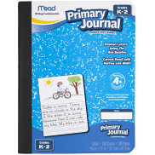

- Dry erase markers, with a small cloth or old sock to use as an eraser
- 2 boxes of tissues
- Pack of disinfectant wipes
- 1 pair of earbuds (in a zip-lock bag labeled with your child’s name)
- 1 roll of paper towel
- 1-2 packs of copy paper

