First Grade
School Supply List 2019-2020

$7.00 for Scholastic News magazine subscription (please send in an envelope labeled with your child’s name)

1 Large zippered pencil case (no plastic boxes, please; they don’t fit in our desks)

6 sturdy folders with bottom pockets (Writing, Homework, Classwork, Tests, Guided Reading, 100 Book Challenge) (plastic/coated folders last longer)

1 Large eraser

1 Box of crayons (16 or 24 only, please)

Scissors

1 Large Glue Stick (these will need to be replaced throughout the year)

Pencils (please send 4 sharpened pencils to school each day) NO MECHANICAL PENCILS- THESE WILL BE SENT BACK HOME

1 Regular Composition Book1 Primary Composition Book/Journal with picture space at the top 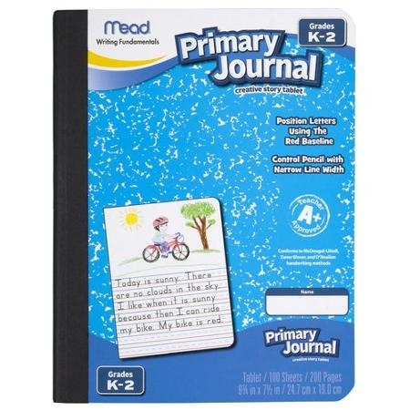
1 Standard/Metric Ruler (12 inches/30 cm)

Dry Erase markers, with a small cloth or old sock to use as an eraser

2 Boxes of Tissues

Pack of disinfectant wipes

Roll of paper towels

Large pack of Post-It/sticky notes (to be used by students during Reading and Math)

1-2 Packs of copy paper

1 pair of earbuds (in a ziplock bag labeled with your child’s name)

