Mrs. Straface

First Grade Room 104

School Supply List 2024-2025

**PLEASE LABEL ALL SUPPLIES WITH YOUR CHILD’S NAME**

1 Large zippered pencil case (no plastic boxes, please; they don’t fit in our desks)

5 sturdy folders with bottom pockets (Writing, Homework, Classwork, Tests, 100 Book Challenge) (plastic/coated folders last longer)

1 Large eraser

1 Box of crayons (16 or 24 only, please)

Scissors

Glue Sticks (these will need to be replaced throughout the year)

Pencils (please send 4 sharpened pencils to school each day) NO MECHANICAL PENCILS- THESE WILL BE SENT BACK HOME

1 Primary Composition Book/Journal with picture space at the top 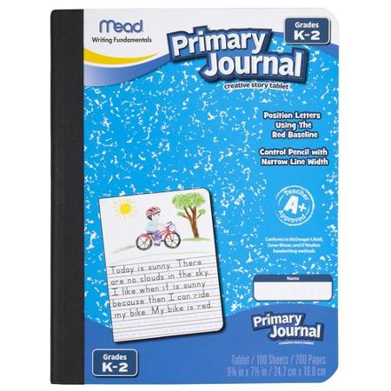

1 Composition Book for Science

|  |
| --- |

Dry Erase markers, with a small cloth or old sock to use as an eraser

2 Boxes of Tissues

2 Packs of disinfectant wipes

1 pair of earbuds or headphones (in a ziplock bag labeled with your child’s name)

Flash Cards: Addition to 20 and Subtraction to 20 (try the Dollar Store or Five Below)

 Wish List items (appreciated but not required ☺ )

Roll of paper towels

Copy paper

Baby wipes

Ziplock bags